**Best Photo Booths Manufacturers in California.**

[**ATA Photobooths**](https://www.ataphotobooths.com/) is the best Photo Booths Manufacturers in California. We offer photo booth rentals for parties, weddings, and events. ATA Photobooths is the most affordable, highest quality photo booth. Check out our Rental Packages and let's get the party started!

Photos are an important part of every event. Whether it’s a birthday party or an anniversary, hiring a professional photo booth is recommended to ensure the quality of the pictures. It is absolutely important that you get a photo booth rental to capture all the wonderful pictures of the special event. Photo Booth helps in preserving memories of your event. There are many companies who offer you photo booth rental services in the USA, but **ATA Photobooths** is the best.

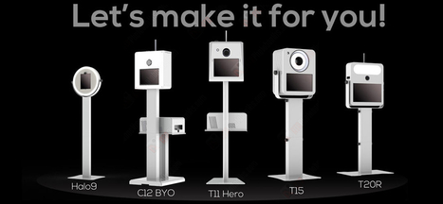

**Packages we offer:**

1. Helio Packages
2. Lumia M Packages
3. T12R (Razor) Packages
4. T20R Photographers Package
5. VeeO Packages.

**Benefits of Hiring a Photo Booth:**

* Offer Unrivalled Entertainment.
* Wedding Photo Booth Is the Ultimate Guestbook.
* Added Vintage Charm.
* People Can Relax and Be Spontaneous.
* A chance to give your occasion extra publicity.

ATA Photobooths is the perfect place to buy a photo booth for your event rental business, marketing agency, activation or experiential marketing event! Our selection includes photo booth kiosks for sale in a wide range of sizes and capabilities. We also have a variety of portable photo booth accessories such as backdrops, photo booth printers and photo booth media. Our mission is to create meaningful business opportunities that allow to people memories.

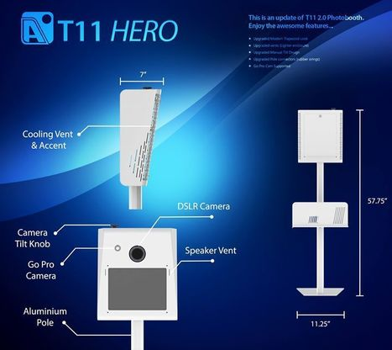

We have manufactures the best **Portable Photo Booths, Mirror Photo Booth, Slim Helio Rolling Case, Lumia Booth Rolling Case, Printers, Printer Covers and iPad photo booths for sale**. Buy a photo booth and start your business today!

If you would like more information on Best Shots Photo Booth or to check availability, please feel free to contact us.

**Email:** info@ataphotobooths.com

**Toll-Free Number:** 1 (888) 530-6661

**Local Number:** 1 (909) 333-7110